1. **KPI’s**

**Pizza sales SQL Query**

1. **Total Revenue**

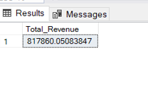SELECT SUM(total_price) AS Total_Revenue FROM pizza_sales ;

1. **Average Order Value**

select sum(total_price) / count(distinct order_id) as Avg_Order_Value from pizza_sales

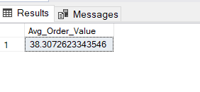

1. **Total Pizza Sold**

select sum(quantity) as Total_Pizza_Sold from pizza_sales

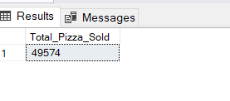

1. **Total Orders**

select count(distinct order_id) as Total_Orders from pizza_sales

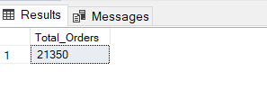

1. **Average Pizzas Per Order**

select cast(cast(sum(quantity) as decimal(10,2) )/

cast(count(distinct order_id) as decimal(10,2)) as decimal(10,2))

as Avg_Pizzas_Per_Order

from pizza_sales

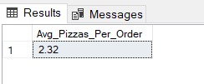

1. **Daily Trend For Total Orders.**

select DATENAME(DW , order_date) as Order_Day , count(distinct order_id) as Total_Orders

from pizza_sales

group by DATENAME(DW , order_date)

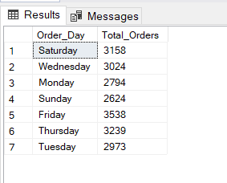

1. **Monthly Trend for Orders.**

select DATENAME(month , order_date) as Month_Name , count(distinct order_id) as Total_Orders

from pizza_sales

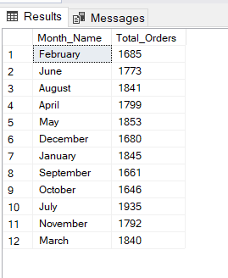group by DATENAME(month , order_date)

1. **% of sales by Pizza Category.**

SELECT pizza_category, CAST(SUM(total_price) AS DECIMAL(10,2)) as total_revenue,

CAST(SUM(total_price) * 100 / (SELECT SUM(total_price) from pizza_sales) AS DECIMAL(10,2)) AS PCT

FROM pizza_sales

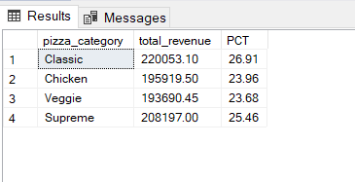GROUP BY pizza_category

1. **% of sales by Pizza size**

SELECT pizza_size, CAST(SUM(total_price) AS DECIMAL(10,2)) as total_revenue,

CAST(SUM(total_price) * 100 / (SELECT SUM(total_price) from pizza_sales) AS DECIMAL(10,2)) AS PCT

FROM pizza_sales

GROUP BY pizza_size

ORDER BY pizza_size

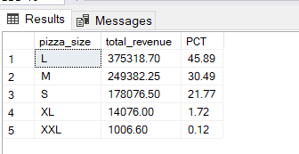

1. **Total Pizzas sold by pizza category**.

SELECT pizza_category, SUM(quantity) as Total_Quantity_Sold

FROM pizza_sales

WHERE MONTH(order_date) = 2

GROUP BY pizza_category

ORDER BY Total_Quantity_Sold DESC

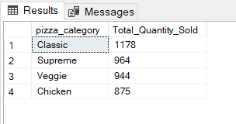

1. **Top 5 Pizzas by revenue.**

select top 5 pizza_name , sum(total_price) as Total_Revenue from pizza_sales

group by pizza_name

order by Total_Revenue DESC

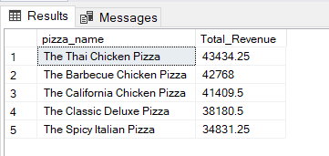

1. **Bottom 5 Pizzas by Revenue.**

SELECT Top 5 pizza_name, SUM(total_price) AS Total_Revenue

FROM pizza_sales

GROUP BY pizza_name

ORDER BY Total_Revenue ASC

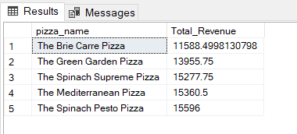

1. **Top 5 Pizzas by Quantity**

SELECT Top 5 pizza_name, SUM(quantity) AS Total_Pizza_Sold

FROM pizza_sales

GROUP BY pizza_name

ORDER BY Total_Pizza_Sold DESC

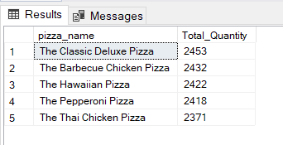

1. **Bottom 5 Pizzas by Quantity.**

SELECT TOP 5 pizza_name, SUM(quantity) AS Total_Pizza_Sold

FROM pizza_sales

GROUP BY pizza_name

ORDER BY Total_Pizza_Sold ASC

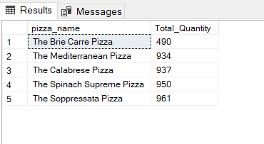

1. **Top 5 pizzas by total orders.**

SELECT Top 5 pizza_name, COUNT(DISTINCT order_id) AS Total_Orders

FROM pizza_sales

GROUP BY pizza_name

ORDER BY Total_Orders DESC

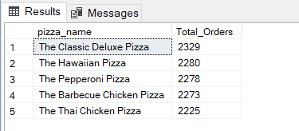

1. **Bottom 5 pizzas by total orders.**

SELECT Top 5 pizza_name, COUNT(DISTINCT order_id) AS Total_Orders

FROM pizza_sales

GROUP BY pizza_name

ORDER BY Total_Orders ASC

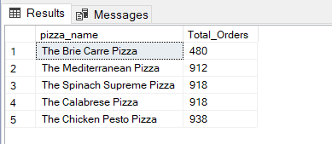

**NOTE**

**If you want to apply the pizza category or pizza size filters to the above queries you can use WHERE clause. Follow some of below examples.**

SELECT Top 5 pizza_name, COUNT(DISTINCT order_id) AS Total_Orders

FROM pizza_sales

WHERE pizza_category = 'Classic'

GROUP BY pizza_name

ORDER BY Total_Orders ASC